Home More! Arts Revisiting the past
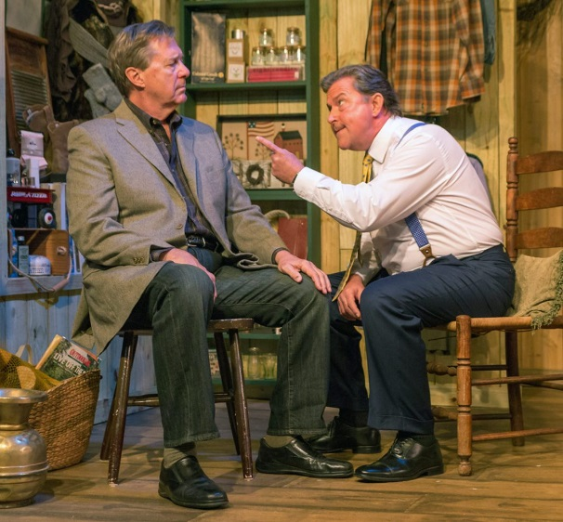

REVISITING THE PAST
New Bowersox play examines life’s twists and turns
By
Katrina Nichols
-
July 6, 2018

One of the biggest questions we might ask ourselves is if we have lived the life we were meant to live, or made a complete mess of it?

In the world premiere of “Under the Hunter’s Moon,” currently at the Red Barn Theater through July 22, Key West playwright, Bob Bowersox has penned a play that gets everyone thinking.

The main character, Hollywood actor Robert Grey, is barely holding it together by the time he gets to Maine to shoot his latest movie, “Under the Hunter’s Moon”. He’s drinking too much and finding no answers at the bottom of the bottle. He’s been accused of acting like a diva on set and holding up production. And he’s romantically involved with his leading lady, Blake Hawthorne (played with just the right measure of femme fatale and vulnerability by Melody G. Moore) who is counting on the movie to be her star vehicle. In the midst of all this, and late again for the set, Robert Grey walks in to the Gilead General Store and comes face-to-face with what could have been — his old college flame, Nancy Benham (Paula Cabot) whom he hasn’t been in contact with for 35 years.
The character of Robert Grey is relentless in trying to get her to also question her life path and yet she doesn’t. He pressures her to see if they still have something between them and she rebuffs him consistently (for reasons that are revealed in small pieces throughout the play). Their bittersweet ending is honest and stays true to the tone of the play.
Grey also tries to convince the general store proprietor, Sam Quinlan (played with a light touch and gentle humor by Mathias Maloff) that he never should have given up painting, but the character finds no discontent in having left his art in the past. His wife, Maggie, (played by Tammy Shanley) is awestruck by Robert Grey and eventually becomes his confidant and sounding board as he tries to sort out life’s big questions. The character of Maggie moves with ease from Robert Grey groupie to his friend to wise counsel — not only for Grey, but also everyone else.
The real hard words come from Grey’s agent, who is afraid he is about to blow the picture. Actor David Black clearly has fun as the shrewd and career-driven Ari Kantar full of wisecracks and strong advice.
Actress Paula Cabot, playing his college sweetheart, uses all her acting muscle and flexibility to convey her inner dilemma and outer guardedness with crossed arms, hard glances, and long silences.
Throughout the play, the sharp dialogue written by Bowersox and the crisp direction of Patrick New make every line count.
The cast is stellar, of course, and yet the set design could easily steal the show. The stage was transformed into a general store, right down to the wood burning stove, barrel of apples and peanuts sitting in the middle of the room and the fully stocked shelves. Coming and going, the cast wearing jeans and fashionable boots with sweaters and jackets easily conveyed the look and feel of people living in and visiting a cold northern town.
Take time to see this thought-provoking and engrossing play before the end of the run on July 22. It just may have you questioning how you have used your time so far on earth and if the path was the right one.
For more information on this and other Summer Stage events, visit keywestsummerstage.com or call TheatreXP at 302-540-6102.

